What I know about ATTILA

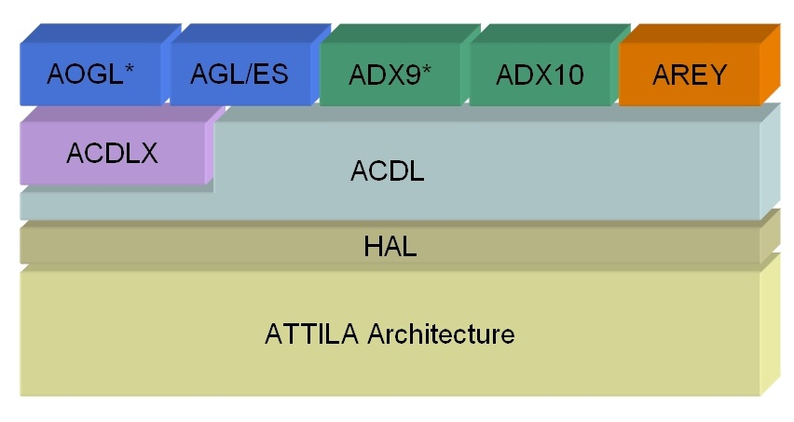

ATTILA separates the hardware and software implementation

Hardware side:

/src/bgpu

/src/emul (simulator without slow timing model)

/src/gpu

Software side:

/src/trace/ACD (ATTILA Common Driver)

/src/trace/AOGL (ATTILA OpenGL Driver)

/src/trace/D3DDriver/AD3D9 (ATTILA DirectX 9 Driver)

(There is a ShaderTranslator under /D3DDriver/D3DControllers/ShaderTranslator)

gl2attila:

This file contains definitions for preprocessor tool that translates a trace of OpenGL API calls in a trace of AGP transactions for the ATILA simulator.

gl2attila -> AGPTransaction ……

AGPTraceDriver -> (depend on using GLTraceDriver / D3DTraceDriver)

For example if we using openGL, then the compiler code we use will be

/src/trace/GLLib/ARBP

/ARBP/ProgramExecutionEnviroment.h decide which compiler to use.

/ARBP/GenericInstruction.h list the instr that ATTILA implemented which has “SLT”